APPENDIX

A1. Example of beliefs elicitation approach

[The following example will help the respondent to understand the concept of probability and how to answer during the survey using the touch-screen tablet. The interviewer reads out the text and then shows the figures on the tablet; the interviewer let’s the respondent play with the screen to get a sense of the probability]

I would like to ask you about the chance or probability that certain events are going to happen. As you know, there are many events in our lives that are uncertain. For example, we can guess about the chance it will rain tomorrow, but cannot say for sure it will rain on any given day. Also, the chance it might rain will also depend on the season. For example, in this rainy season (April – June), you might expect that there is a high chance that it will rain tomorrow. But there is no guarantee that it will rain for sure.
On the other hand, if I had asked you this question about a day in the dry season (January – March), you might have expected that the chance of rain is very low. But again, completely unexpected rains can arrive even in March!
Using this screen, you can express how certain you think these uncertain events might occur (like whether it will rain tomorrow). When the ball is in the middle of the line, it shows you think it is equally likely that it will rain or not rain.
As you move the ball towards the RAIN, you indicate that you are more and more certain it will rain. If you slide it all the way to the right, you are 100% absolutely certain it will rain.

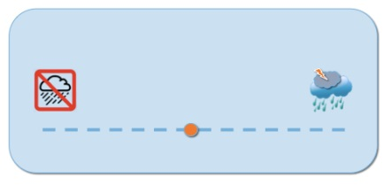

(Example of equal probability of rain and no rain)
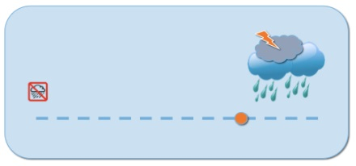

(Example of 7 out of 10 chance of rain tomorrow)
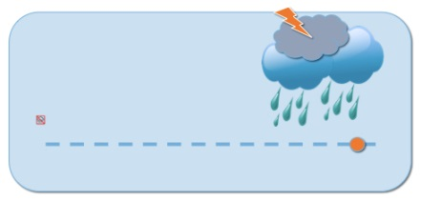

Note that in this last example, the ball is not all the way at the end, indicating a very high probability it could rain, but there is a small chance it might not rain. This is an example of a 99% chance.

How likely is that it will rain tomorrow?

A2. Additional figures

Figure 1: Revision process of belief of having malaria

Notes: This figure represents the revision process of the beliefs of having malaria. Prior belief of having malaria refers to the elicited belief at baseline. “Change” refers to the difference between posterior (at one week follow-up) and prior (at baseline) belief of having malaria. We do not observe beliefs right after testing.

Figure 2: Density of probability of believing having malaria by time, among tested individuals

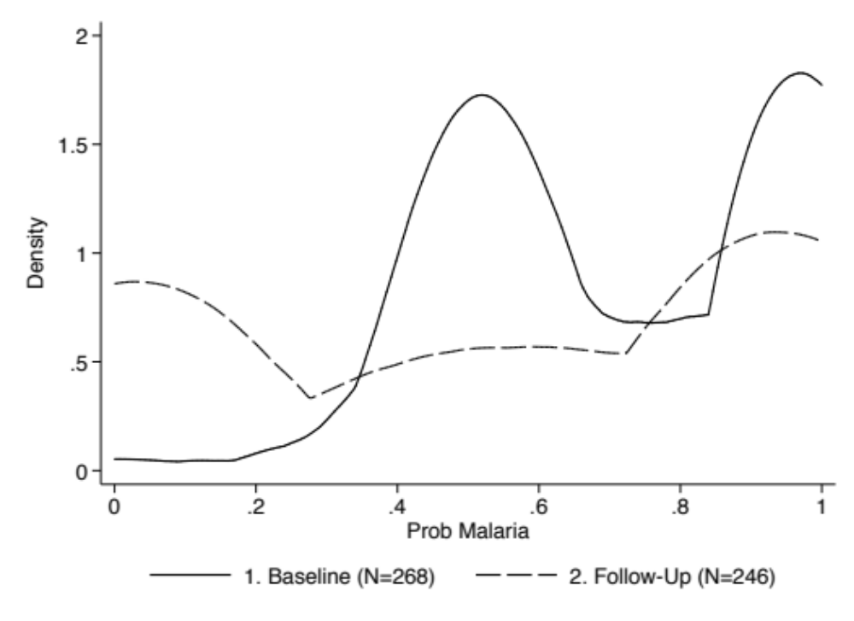

Notes: This figure represents the density of the probability of believing having malaria, by time of data collection (baseline and follow-up).

Figure 3: Prior beliefs: How likely is it that your illness today is malaria?

Notes: This figure represents the average probability (in percentages) that the illness the patient had was malaria, as elicited at baseline. We record the number of observations per each category of individuals in parenthesis. Missing data on ACT purchasing behavior or test results explains why the number of observations in few sub groups does not always sum up perfectly. Red boxes highlight statistically significant association (p-value<0.1) between prior belief of having malaria and the ACT purchasing behavior.

Figure 4: Posterior beliefs: How likely is it that the illness you had one week ago was malaria?

Notes: This figure represents the average probability (in percentages) that the illness the patient had one week before was malaria, as elicited at follow-up. We record the number of observations per each category of individuals in parenthesis. Missing data on ACT purchasing behavior or test results explains why the number of observations in few sub groups does not always sum up perfectly. Red boxes highlight statistically significant association (p-value<0.1) between individual ACT purchasing behavior and posterior belief of having malaria. Note that the posterior belief of having malaria was asked only to individuals tested for malaria.

A3. Additional tables

Table 1: Participant characteristics by study group (Prudhomme O’Meara et al. 2016)

 | Group A:  ACT Subsidy  RDT Subsidy  N=116 | Group B:  RDT Subsidy  N=107 | Group C:  ACT Subsidy  N=114 | Group D:  No Subsidy  (Reference)  N=107 | Total  N=444
Female | 71 (61%) | 63 (59%) | 76 (67%) | 69 (64%) | 279 (63%)
Patient age (years)
0 to 5 | 38 (33%) | 28 (26%) | 35 (31%) | 23 (21%) | 124 (28%)
>5 to <18 | 41 (35%) | 32 (30%) | 32 (28%) | 45 (42%) | 150 (34%)
18 to <35 | 22 (19%) | 23 (21%) | 21 (18%) | 15 (14%) | 81 (18%)
35+ | 15 (13%) | 24 (22%) | 26 (23%) | 24 (22%) | 89 (20%)
Household size
Median (IQR) | 6 (5, 7) | 6 (4, 8) | 6 (5, 7) | 6 (5, 8) | 6 (4, 7)
Highest Level of Education Completed
< Primary or None | 3 (3%) | 2 (2%) | 5 (4%) | 3 (3%) | 13 (3%)
Primary | 69 (59%) | 67 (63%) | 71 (62%) | 72 (67%) | 279 (63%)
Secondary | 44 (38%) | 38 (36%) | 38 (33%) | 32 (30%) | 152 (34%)
Occupation
Farming | 73 (63%) | 64 (60%) | 69 (61%) | 69 (64%) | 275 (62%)
Unemployed | 11 (9%) | 13 (12%) | 16 (14%) | 13 (12%) | 53 (12%)
Employed | 13 (11%) | 10 (9%) | 8 (7%) | 9 (8%) | 40 (9%)
Self-Employed/Other | 19 (16%) | 20 (19%) | 21 (18%) | 16 (15%) | 76 (17%)
Wealth Category
Poorest 40th percentile | 45 (40%) | 36 (36%) | 45 (40%) | 46 (44%) | 172 (40%)
Distance to facility (km) | 2.1  (1.5, 2.8) | 2.2  (1.6, 2.7) | 2.2  (1.5, 2.9) | 2.0  (1.4, 2.8) | 2.2  (1.5, 2.8)
Median (IQR)
Distance to enrolled  shop (km) | 1.4  (1.0, 2.1) | 1.6  (0.9, 2.2) | 1.6  (1.0, 2.1) | 1.7  (1.0, 2.1) | 1.6  (1.0, 2.2)
Median (IQR)
Has one-week follow-up | 116 (100%) | 103 (96%) | 114 (100%) | 104 (97%) | 437 (98%)

Notes: This table presents summary statistics on the sample, by study group. Please refer to Prudhomme O’Meara et al. (2016) for detailed information on the study setting.

Table 2: Linear probability model estimates of the association between prior beliefs and malaria testing behavior (non-linear relationship between belief and behavior)

Dependent Variable: Had Any Malaria Test
 | Model 1 | Model 2 | Model 3
 | (1) | (2) | (3)
Prob having malaria (Tertile 1st) | -0.0344 | -0.0482 | -0.0434
 | (0.0582) | (0.0587) | (0.0592)
Prob having malaria (Tertile 3rd) | -0.0150 | 0.0156 | 0.0121
 | (0.0644) | (0.0655) | (0.0667)
RDT discount | 0.239*** | 0.233*** | 0.231***
 | (0.0459) | (0.0463) | (0.0466)
ACT discount | -0.0258 | -0.0331 | -0.0354
 | (0.0462) | (0.0465) | (0.0469)
Prob test negative correct | 0.0910 | 0.0855 | 0.0943
 | (0.0869) | (0.0893) | (0.0907)
Prob test positive correct | -0.0122 | -0.0383 | -0.0479
 | (0.0861) | (0.0909) | (0.0927)
ACT more effective (Dummy) |  |  | 0.00347
 |  |  | (0.0507)
Admission to hospital - Severity |  |  | 0.142
 |  |  | (0.203)
Admission to hospital - Progression over time |  |  | 0.0617
 |  |  | (0.130)
Enumerator fixed effects | Yes | Yes | Yes
Community fixed effects | Yes | Yes | Yes
Socio-demographic controls | No | Yes | Yes
Dep Var Mean | 0.622 | 0.622 | 0.622
N | 421 | 413 | 412

Notes: This table presents linear probability model estimates of the association between prior beliefs and malaria testing behavior. Socio-demographic controls include age, gender, education level, occupation, wealth (in the lowest 40th percentile of income distribution) and household size of respondent (patient and guardian if patient <18years), gender of patient, and a dummy equal to 1 if respondent is the same as the patient. Enumerators fixed effects include a dummy per each of the 8 enumerators. Communities fixed effects include a dummy per each of the 3 communities. The variable "ACT more effective" is a binary indicator for whether the respondent believes ACTs are more effective than another common antimalarial drug, Sulfadoxine/Pyrimethamine (Fansidar, SP); The variable "Admission to hospital - Severity" is constructed as mean between probability of being admitted to the hospital in 2 days, 5 days, 2 weeks. The variable "Admission to hospital - Progression over time" is constructed as the difference between probability of being admitted to the hospital in 2 weeks and 2 days. The probability of malaria is split in tertiles (low, middle, high) based on the distribution. The excluded category in the analysis is the indicator for whether the prior probability of having malaria is in the second tertile of the distribution. Standard errors in parentheses. *p<0.1 ** p<0.05 *** p<0.01.

Table 3: Linear probability model estimates of the association between prior beliefs and RDT/ACT discounts, and malaria testing behavior (linear relationship between beliefs and discounts, and behavior)
Dependent Variable: Had Any Malaria Test
 | Model 1 | Model 2 | Model 3
 | (1) | (2) | (3)
Prob having malaria | 0.0688 | 0.0343 | 0.0146
 | (0.186) | (0.191) | (0.193)
RDT discount | 0.397*** | 0.319** | 0.322**
 | (0.146) | (0.152) | (0.153)
ACT discount | -0.0679 | -0.0982 | -0.103
 | (0.144) | (0.147) | (0.149)
Prob having malaria X RDT discount | -0.218 | -0.119 | -0.126
 | (0.191) | (0.198) | (0.199)
Prob having malaria X ACT discount | 0.0604 | 0.0956 | 0.0980
 | (0.189) | (0.194) | (0.196)
Prob test negative correct | 0.0894 | 0.0821 | 0.0922
 | (0.0861) | (0.0889) | (0.0902)
Prob test positive correct | -0.00753 | -0.0264 | -0.0387
 | (0.0855) | (0.0910) | (0.0931)
ACT more effective (Dummy) |  |  | -0.00287
 |  |  | (0.0507)
Admission to hospital - Severity |  |  | 0.171
 |  |  | (0.207)
Admission to hospital - Progression over time |  |  | 0.0772
 |  |  | (0.132)
Enumerator fixed effects | Yes | Yes | Yes
Community fixed effects | Yes | Yes | Yes
Socio-demographic controls | No | Yes | Yes
Dep Var Mean | 0.622 | 0.622 | 0.622
N | 421 | 413 | 412
Notes: This table presents linear probability model estimates of the association between prior beliefs and malaria testing behavior. The models also include interaction terms between RCT and ACT discounts, and the prior probability of having malaria. Socio-demographic controls include age, gender, education level, occupation, wealth (in the lowest 40th percentile of income distribution) and household size of respondent (patient and guardian if patient <18years), gender of patient, and a dummy equal to 1 if respondent is the same as the patient. Enumerators fixed effects include a dummy per each of the 8 enumerators. Communities fixed effects include a dummy per each of the 3 communities. The variable "ACT more effective" is a binary indicator for whether the respondent believes ACTs are more effective than another common antimalarial drug, Sulfadoxine/Pyrimethamine (Fansidar, SP); The variable "Admission to hospital - Severity" is constructed as mean between probability of being admitted to the hospital in 2 days, 5 days, 2 weeks. The variable "Admission to hospital - Progression over time" is constructed as the difference between probability of being admitted to the hospital in 2 weeks and 2 days. Standard errors in parentheses. *p<0.1 ** p<0.05 *** p<0.01.

Table 4: Linear probability model estimates of the association between prior beliefs and malaria testing behavior (linear relationship between beliefs and behavior), by age of the patient

Dependent Variable: Had Any Malaria Test
 | (1) | (2) | (3)
 | Under 5 | 5 to 17 | 18+
Prob having malaria | 0.173 | 0.265 | -0.161
 | (0.273) | (0.206) | (0.183)
RDT discount | 0.254** | 0.174** | 0.317***
 | (0.107) | (0.0731) | (0.0794)
ACT discount | 0.0498 | -0.0569 | -0.0286
 | (0.116) | (0.0783) | (0.0806)
Prob test negative correct | 0.337* | 0.238 | -0.237*
 | (0.194) | (0.153) | (0.138)
Prob test positive correct | -0.116 | -0.168 | 0.135
 | (0.178) | (0.153) | (0.146)
ACT more effective (Dummy) | -0.0524 | -0.0318 | -0.0417
 | (0.124) | (0.0807) | (0.0837)
Admission to hospital - Severity | -0.0902 | 0.470 | 0.00372
 | (0.478) | (0.306) | (0.374)
Admission to hospital - Progression over time | 0.108 | 0.161 | -0.0664
 | (0.250) | (0.210) | (0.234)
Enumerator fixed effects | Yes | Yes | Yes
Community fixed effects | Yes | Yes | Yes
Socio-demographic controls | Yes | Yes | Yes
Dep Var Mean | 0.620 | 0.639 | 0.607
N | 94 | 162 | 156

Notes: This table presents linear probability model estimates of the association between prior beliefs and malaria testing behavior (Model 3) by age of the patient. Socio-demographic controls include age, gender, education level, occupation, wealth (in the lowest 40th percentile of income distribution) and household size of respondent (patient and guardian if patient <18years), gender of patient, and a dummy equal to 1 if respondent is the same as the patient. Enumerators fixed effects include a dummy per each of the 8 enumerators. Communities fixed effects include a dummy per each of the 3 communities. The variable "ACT more effective" is a binary indicator for whether the respondent believes ACTs are more effective than another common antimalarial drug, Sulfadoxine/Pyrimethamine (Fansidar, SP); The variable "Admission to hospital - Severity" is constructed as mean between probability of being admitted to the hospital in 2 days, 5 days, 2 weeks. The variable "Admission to hospital - Progression over time" is constructed as the difference between probability of being admitted to the hospital in 2 weeks and 2 days. Standard errors in parentheses. *p<0.1 ** p<0.05 *** p<0.01.

